Tigermed Interview Prep

Links
https://www.linkedin.com/company/tigermed-consulting-ltd-/about/
https://www.tigermed.net/
Interviewer
Stephanie Geddings
https://www.linkedin.com/in/stephanie-geddings-m-s-530a371b/

Overview

Overview
Tigermed (Stock code: 300347.SZ/3347.HK) is a leading provider of innovative clinical research solutions across full lifecycle of biopharmaceutical and medical device products globally. With a broad portfolio of services and a promise of quality, from clinical development to commercialization, we are committed to moving our customers and patients through their development journey efficiently and cost-effectively. Tigermed currently represents a worldwide network of more than 60 subsidiaries and 150 offices and sites, with over 6,400 employees across 38 countries in Asia Pacific, Europe, North & South America and Africa. We are devoted to building an integrated platform that enables boundless possibility for the healthcare industry, embracing challenges to fulfill our commitment to serve unmet patients’ needs, and eventually saving lives.

Company size - 6,400 employees
Headquarters - Shanghai, Shanghai
Type - Public Company
Founded - 2004
Specialties - BE study Generic Drugs Quality Consistency Evaluation, Preclinical/CMC/Bioanalytical, Clinical related services, Regulatory Affairs, Clinical trial---Phase I to IV & NIS, and MART&Oversea clinical service

Insights
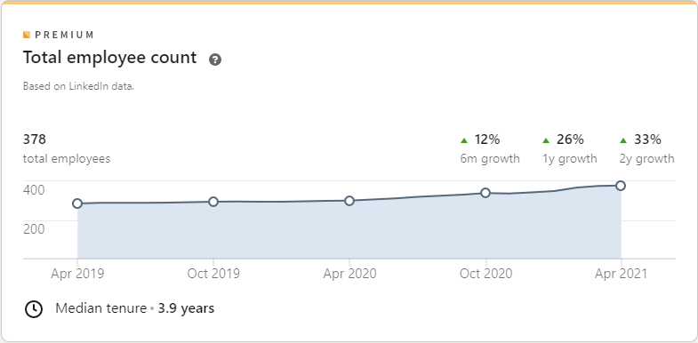

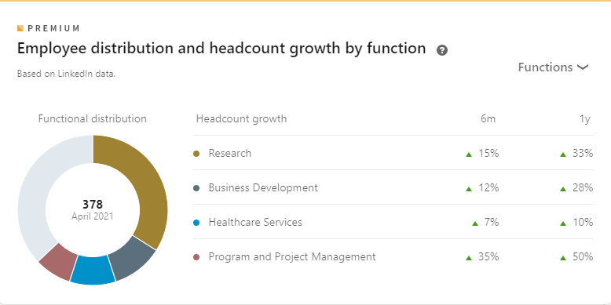

**You would be starting perm not contract

Tigermed- Clinical Data Manager- Remote (Multiple Potential Openings)
6 to 12 month renewable contract and opportunity to convert Perm

Job Description for Clinical Data Manager:
About our company: Tigermed – BDM Inc. is a progressive, fast-growing Clinical Research Organization currently based in Somerset, NJ. This US-based Tigermed division provides a ‘start-up’ like atmosphere with many benefits including: 1) Excellent opportunities for career growth, 2) Recognition of your work contributions, and 3) A flexible, approachable management team. The company is backed by a medium-sized, global CRO and supported by sufficient funding and resources with the opportunity to transition into a permanent role after 6 months.
About the position: We are currently recruiting a full-time, remote-based Clinical Data Manager (consultant) experienced in all CDM start-up, maintenance and closeout activities to coordinate/lead and perform day-to day Data Management activities. Will work closely with DM project manager to ensure end to end Data Management coverage of all assigned studies and consistency across study program. Hours are flexible with core hours of 9:30am -3:30pm Eastern.
Key Responsibilities may vary but will generally include:
• Review protocol and attend protocol review meetings or provide feedback, as needed.
• Provide feedback, as requested, during development of eCRF specifications according to the protocol.
• Assist in the design and review of study databases.
• Author or review eCRF completion guidelines.
• Develop or lead the review of a Data Management Plan (DMP), when applicable, that outlines database design and testing, data review and query handling, coding, SAE reconciliation, external data reconciliations, reports, data lock and archiving, etc.
• Develop or lead the review of edit check specifications, as well as perform/coordinate UAT.
• Provide study metrics and status reports to internal and/or client teams.
• Provide updates to team questions on program tasks and scope.
• Perform or lead data cleaning activities.
• Perform or lead SAE reconciliation activities.
• Perform or lead external data reconciliation activities.
• Perform or lead database lock and freeze activities.
• Assist or generate study timelines.
• Ensure approved study documents are maintained and properly stored in trial master file.
Basic Qualifications:
- BS/BA degree or equivalent
- Minimum 5-7 years of experience in a pharmaceutical/CRO setting
• Advanced knowledge of Clinical Data Management process and challenges
• Proficient knowledge of Medidata RAVE, Oracle InForm and/or IBM Clinical Development
• Comprehension of the principles of quality, safety, risk management and compliance (ICH and GCP).
• Excellent verbal and written communication and problem-solving skills
• Flexible, self-starter who thrives independently, as well as in collaboration with other Clinical Trial professionals in a Global environment
Preferred Qualifications:
• Proficient knowledge of CDISC CDASH and SDTM terminology
We offer a competitive salary. Salary will be commensurate with experience and education level.
edit

